
Business Question and Visualization Report

Date | 26 October 2026
Team ID
Project Name | Electric Vehicle Market Performance & Insights
Maximum Marks | 5 Marks

Visualization development refers to the process of creating graphical representations of data to facilitate understanding, analysis, and decision-making. The goal is to transform complex datasets into visual formats that are easy to interpret, enabling users to gain insights and make informed decisions. Visualization development involves selecting appropriate visual elements, designing layouts, and using interactive features to enhance the user experience. This process is commonly associated with data visualization tools and platforms, and it plays a crucial role in business intelligence, analytics, and reporting
Business Questions and Visualisation
The process involves defining specific business questions to guide the creation of meaningful and actionable visualizations in Tableau. Well-framed questions help in identifying key metrics, selecting relevant data, and building visualisation that provide insights.
Team Member: Self
Business Questions and Visualisation
The following eight questions are based on the supplied ev_market_test.csv dataset and correspond to the Tableau analysis in the project. Each visualisation preview is generated from the same supplied dataset.
1. Which manufacturers have the highest recorded annual sales?
Visualisation: Horizontal bar chart – SUM(annual_sales_units) by manufacturer; sorted descending and limited to the top 10.
Chart preview generated from the supplied dataset:
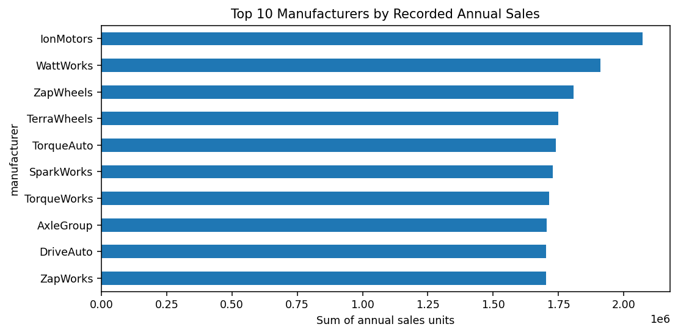
2. How are vehicle records distributed across battery technologies?
Visualisation: Pie chart – COUNTD(vehicle_id) by battery_type. This shows the distribution of records in the supplied dataset, not verified real-world market share.
Chart preview generated from the supplied dataset:
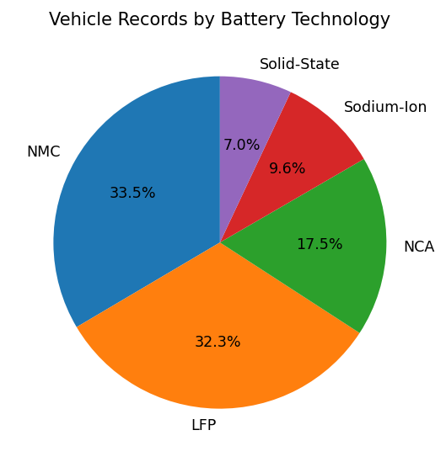

3. Which manufacturers have the highest average driving range?
Visualisation: Horizontal bar chart – AVG(range_km) by manufacturer; top 10 manufacturers.
Chart preview generated from the supplied dataset:
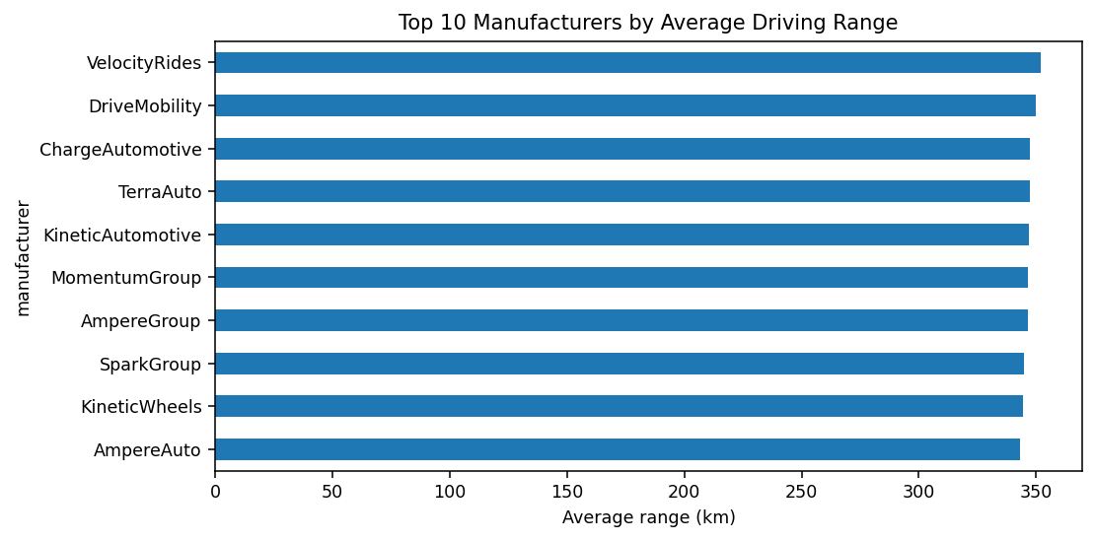
4. What relationship is visible between battery capacity and driving range?
Visualisation: Scatter plot – battery_capacity_kwh against range_km, coloured by battery_type. The chart shows association only and does not establish causation.
Chart preview generated from the supplied dataset:
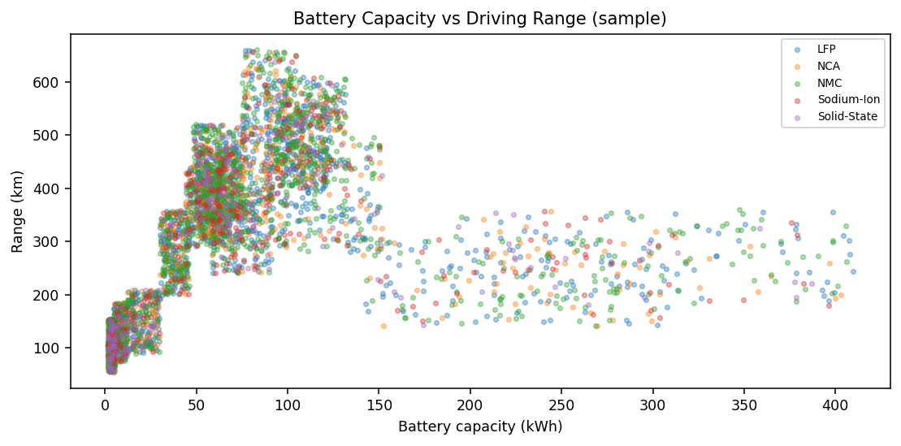

5. Which manufacturing countries have the most vehicle records?
Visualisation: Horizontal bar chart – COUNTD(vehicle_id) by manufacturing_country; top 10 countries. Record counts are not factory output or production volumes.
Chart preview generated from the supplied dataset:
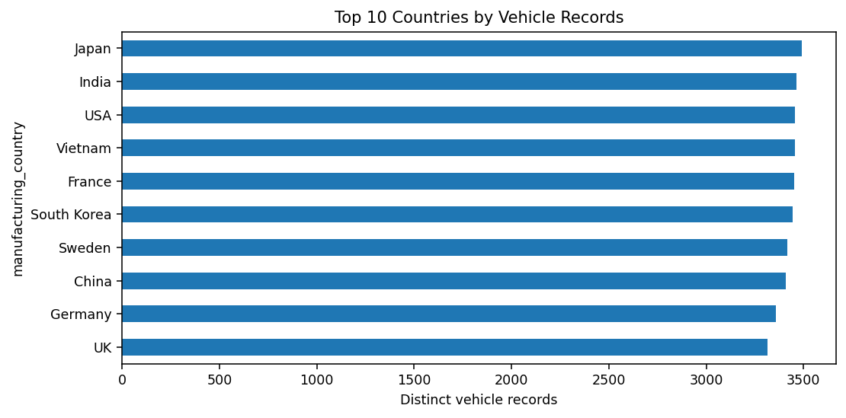
6. Which manufacturers have the highest average customer ratings?
Visualisation: Horizontal bar chart – AVG(customer_rating) by manufacturer; top 10 using available non-null ratings.
Chart preview generated from the supplied dataset:
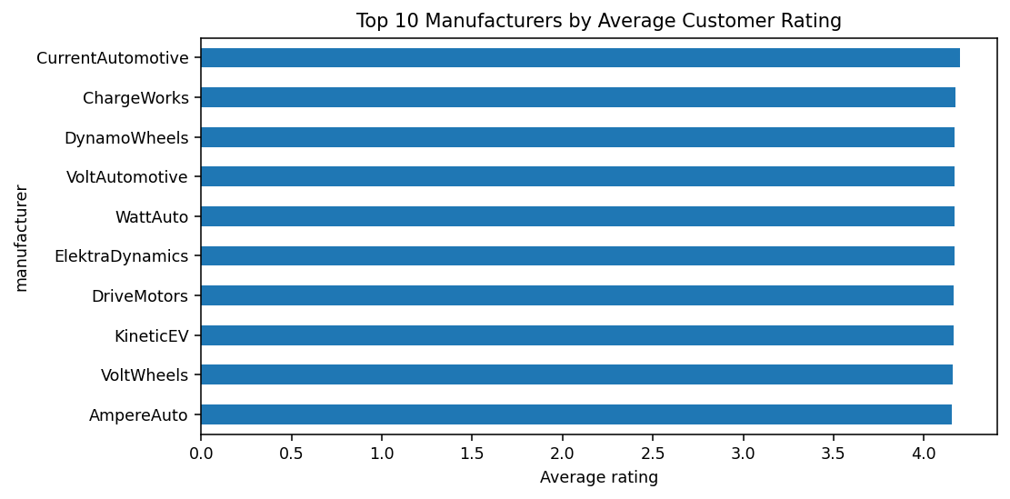

7. How does average battery capacity vary by battery technology?
Visualisation: Horizontal bar chart – AVG(battery_capacity_kwh) by battery_type.
Chart preview generated from the supplied dataset:
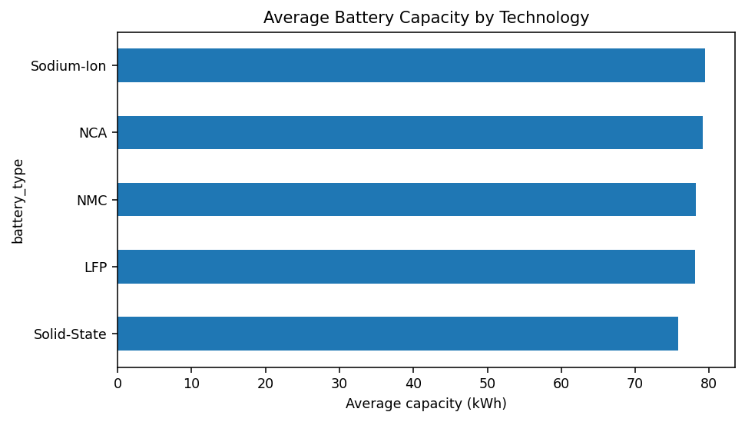
8. How do recorded annual sales vary by model year?
Visualisation: Line chart – SUM(annual_sales_units) by model_year. This is grouped by model year, not transaction year.
Chart preview generated from the supplied dataset:
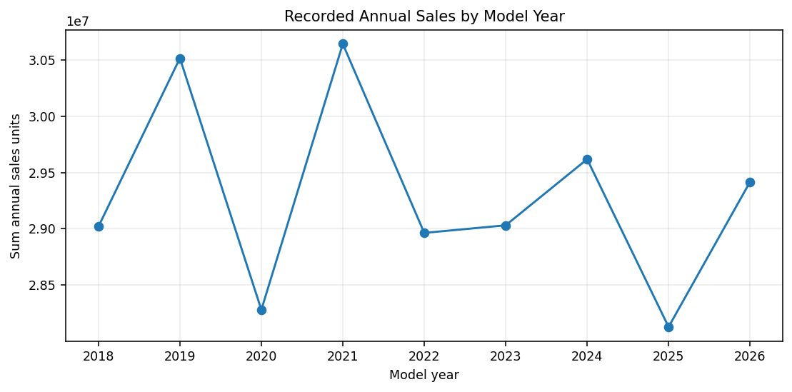
Data and interpretation notes
Dataset: ev_market_test.csv (34,259 rows and 37 columns, as profiled for this project). Missing values are present in some fields, including annual_sales_units and customer_rating; calculations use available values and do not treat missing values as zero. All results describe the supplied test dataset and should not be presented as verified global EV market statistics. Battery-type and country counts represent dataset records. The model_year chart is not a transaction-time sales trend.
Published project links
GitHub repository: https://github.com/suryadevsingh0225/Electric-Vehicle-Market-Performance-Insights
GitHub Pages website: https://abhijeet623.github.io/ELECTRIC-VEHICLE-MARKET-PERFORMANCE-INSIGHTS/
Tableau dashboard: https://public.tableau.com/app/profile/suryadev.singh/viz/EV_Market_Performance_Insights_17931646155280/ELECTRICVEHICLEMARKETPERFORMANCEINSIGHT?publish=yes
Tableau Story 1: https://public.tableau.com/app/profile/suryadev.singh/viz/EV_Market_Performance_InsightsStory1/EVMarketPerformanceOverview?publish=yes
Tableau Story 2: https://public.tableau.com/app/profile/suryadev.singh/viz/EV_Market_Performance_InsightsStory2/EVTechnologyandCustomerInsights?publish=yes
Evidence note: The eight inserted images are dataset-derived chart previews, not screenshots captured from Tableau Public. If the evaluator specifically requires screenshots of the Tableau interface, replace or supplement these previews with actual screenshots from the published workbook.

